**Lanciani MDF/RELIEF Board product standardization**

Division (Architectural Millwork)

Lanciani requires 1-4 weeks of standard lead time for most of its MDF/Relief board products. The specific delivery schedule of each purchase order is determined when the final confirmed drawing is received and the required volume and model are determined. The delivery schedule is calculated based on the principle of first-come-first-served and solely dependent on the current work load. Lanciani does not charge additional fees for urgent orders or allow additional costs. All the ordered items are produced as soon as possible in accordance with the order of the received POs.

The MDF/Relief board products of Lanciani provide a wide choice of 3-dimensional patterns, textures, colors, and installation specifications. In order to produce products exactly in accordance with the dimensional requirement of the customers, it is important to know the available options for the products. The conditions and options of the product specifications are illustrated with images as follows;

The MDF/Relief board products have obtained the “LEED” certification, and they are environmentally-friendly board products with the COC certificate of the FSC. These products are mainly used for wall panels, flush doors, furniture doors, and other indoors applications. And, it is also possible to serve custom orders. In order to make decisions on the available thickness and sizes of the panels, please refer to the specific pattern page. Additional lead time would be required in the cases of non-standard sizes or thickness of the panels.

**Pattern number:**

Each pattern has its name, such as “Sandflow”, “Flysh”, “Pyroclastic Surge“, “Waffle”, ”Wave” and “Ripple”. And, they are endowed with the unique identification numbers in accordance with their patterns. Visit www.lancianiworks.com to visit the webpages where you find out more about the characteristics of each pattern and the actual products using the patterns. It is recommended to request for a sample to check the forms and sizes of the 3-d patterns and the shapes, colors, and directions of the patterns before placing an order.

**Size of the board product:**

The standard board product size is ① 48” x 96” (4’ x 8’). The custom-order board products sizes are ② 48” x 108” (4’ x 9’), ③ 48” x 120” (4’ x 10’), and ④ 48” x 143” (4’ x 12’), while the width is fixed at 48". The length is available up to 143” or even longer. Please contact Lanciani to find out the availability of the materials necessary for your projects. With regard to the projects which require board products of different sizes, what the customers need to do is to send an elevation drawing containing the dimensions to the email address, [lanciani@naver.com](mailto:lanciani@naver.com) or [altnature123@gmail.com](mailto:altnature123@gmail.com). The files can be either *.DXF, *.DWG, and *PDF. However, we recommend the *.DWG format.

**Depth of the patterns:**

This means the deepest depth given to realize the 3-dimensional patterns. The value should be within a range of 1.2mm to 5.7mm.

**Thickness of the board:**

The board thickness means the final thickness after all production processes. After the production processes, the thickness at the thickest place of the board may slightly be lower than the normal board thickness. The thickness of the boards may differ by the pattern series.

Division-1

|  |  |  |
| --- | --- | --- |
| **PATTERN NAME** | | |
| **Sand Flow** | **Flysch** | **Waffle** |
| 8.7mm | 5.3mm | 5.3mm |
| 11.7mm | 8.3mm | 8.3mm |
| 14.7mm | 11.3mm | 11.3mm |
| 17.7mm | 17.3mm | 17.3mm |
| 20.7mm | 21.3mm | 21.3mm |
| 23.7mm | 23.3mm | 23.3mm |
| 25.7mm | 25.3mm | 25.3mm |

Division-2

|  |  |  |
| --- | --- | --- |
| **PATTERN NAME** | | |
| **Pyroclastic Surge** | **Wave** | **Ripple** |
| 5.8mm | 4.7mm | 4.2mm |
| 9.8mm | 7.7mm | 7.2mm |
| 11.8mm | 11.7mm | 11.2mm |
| 15.8mm | 13.7mm | 13.2mm |
| 17.8mm | 16.7mm | 16.2mm |
| 20.8mm | 19.7mm | 19.2mm |
| 25.8mm | 21.7mm | 24.2mm |

The final thickness of the board depends on various factors, such as the type of the 3-dimensional patterns, surface finishing materials, types of paints, and number of paint layers.

**Direction of the pattern:**

Most of the 3-dimensional patterns are formed along the horizontal direction. This may be different from the directions of the patterns. With the image as the reference, the pattern’s direction is called horizontal if the texture of the pattern is connected in short distances and vertical if in long distances. Being horizontal or vertical in directions has nothing to do with the installation direction. The directions of some parts are not clearly discernable. Therefore, in order to determine the desired directions, it is necessary to referring to the photos of each pattern in the catalog.

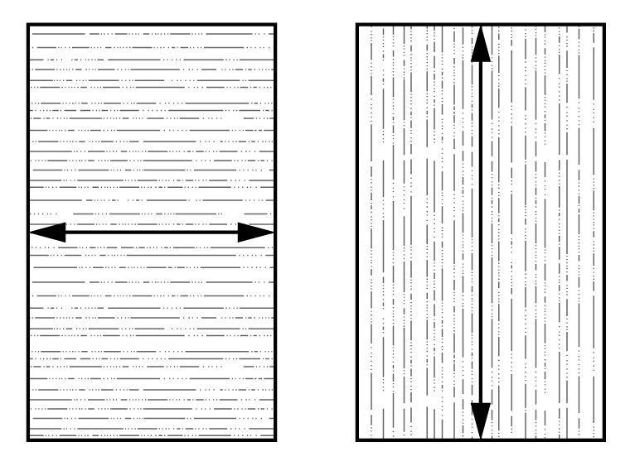

Horizontal Vertical

**Pattern repetition:**

Most of the patterns are manufactured so that the direction of the patterns on the surface is consistent, so that the texture can be connected naturally from one board to another. Based on the requirement of the customer and the pattern, this connectivity can be achieved in different methods. The connection of patterns from one board product to another is referred to the ‘repetition.’ The repetition of each pattern is indicated in the ‘detailed patterns’ section of the catalog. The different repetitions are explained below.

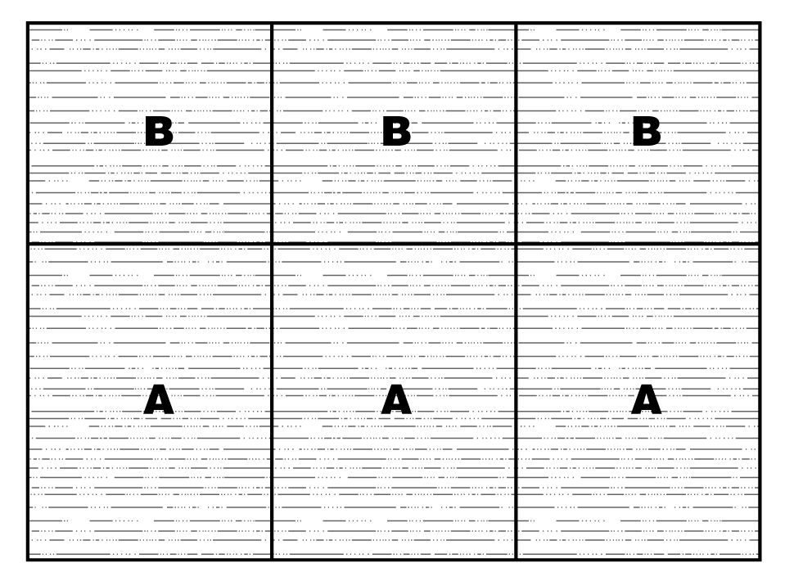

An example of the connectivity of patterns in a 6-board part

When a board product with connectivity is ordered, the consumer should provide the layout and dimension of each board product model to be used in the project. Most of patterns have connectivity. For their specific applications, please contact Lanciani.

The repetition of patterns – the repeating pattern allows the user to understand the project site and fill up with each standard 4’ x 8’ size board products. This standard board product connects to the neighboring boards from top to bottom and from left to right to form a consolidated appearance. In the image below, it is shown that the five same repeating patterns gets at each corner. As for the directions of all board products, it is recommended to maintain their directions in order to allow repetition, but final decisions should be made by consumers.

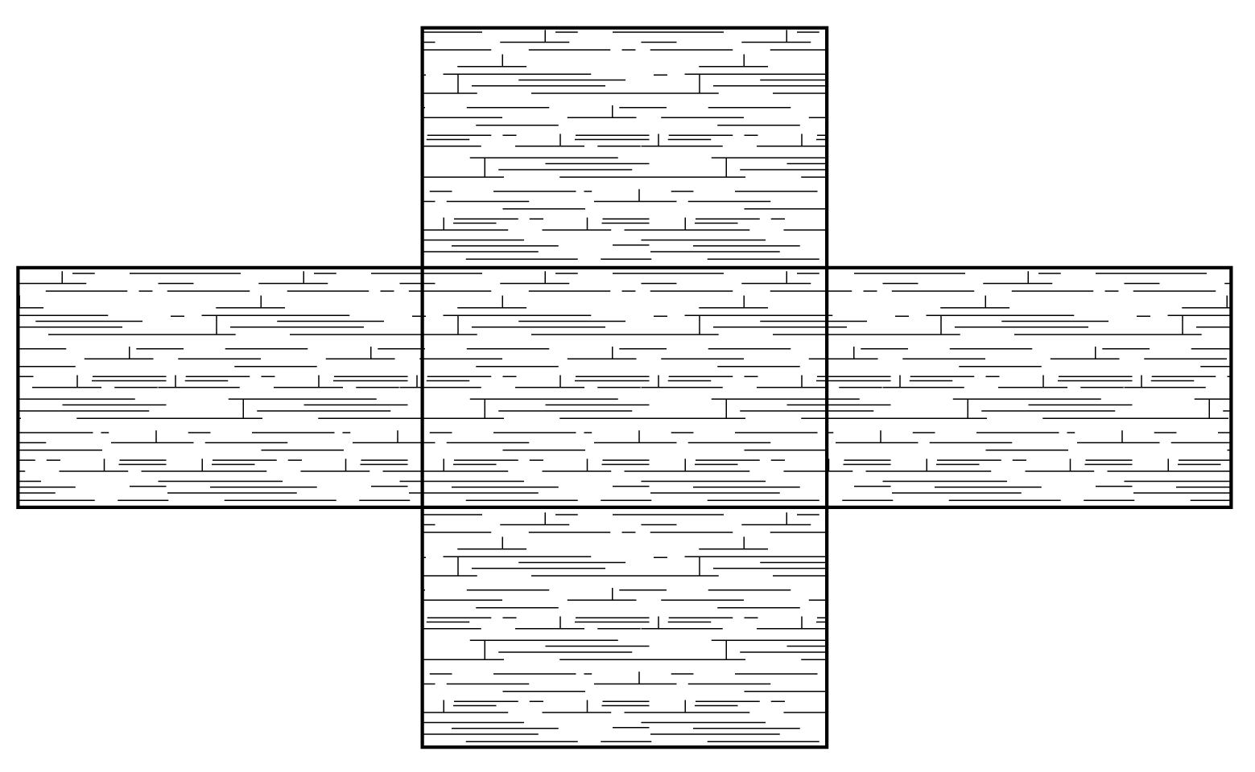

Installation instruction:

The following information is a summary of the published information on the use and application of the engraved MDF RELIEF PANEL products. This publication has been created in order to provide useful tools and ‘information exchange’ rather than strict instructions. Each application corresponds to a unique environment. And, the various site conditions resulted in the summarization of the technologies and exemplary cases available in order to achieve the same results.

The MDF RELIEF PANEL products can be extended linearly by +/-.33%. Wood is a material that absorbs moisture. Under normal conditions of usage, all wood products contain a certain degree of moisture. Woo materials are capable of immediate exchanging of moisture in vapor and molecules with the atmosphere in accordance with the present relative humidity.

In a high humidity, the wood material absorbs moisture and expands; in a low humidity environment, the humidity is discharged and the wood material shrinks. Here, if there is a slight change in the humidity, the dimensional response in a properly designed building is negligible. In order to avoid such a problem, it is recommended to maintain the relative humidity within 25% to 50%. An extreme condition- 20% or lower or 80% or higher – may cause problems. When an order is received from the customer, the board product should be stored in an air-conditioned area and stand for at least three days in order to adjust to the existing humidity conditions (without exceeding the range above.) This humidity level is the humidity level that should be maintained when the product is exposed in the space. In order to prevent sagging or twisting of the board product, it is important to store the products on a flat surface, with the top side facing upward.

In order to save the cost and prevent damages to the packages, the board products are delivered with the products packaged so that the rear sides of the products face each other, while the top side faces another product’s topside. Therefore, after removing the packing and having the products adjust to the humidity condition, it is imperative to place the products facing upward. When an MDF RELIEF PANEL product is finished, the top of the board is removed, creating the “Imbalance Board Effect.” The intensity of this effect depends on the pattern and thickness of the board. In order to help reducing this effect and facilitate the installation process, it is possible to attach a plywood backer to each board. Any MDF product would naturally sag or twist over time. This is not a unique condition that is exclusively happening with our products. Such symptoms can be corrected through the installation techniques. In this document, some of such techniques will be introduced.

An MDF RELIEF PANEL wood product’s proper average moisture content is 4 to 6%. They are made of dried recycled/recovered wood chips entirely. And, this condition should be maintained until the time of shipment. Lanciani should not adjust the conditions to which the boards are exposed during the storage and shipping process. The changes in the dimensions that happen subsequently in the MDF RELIEF PANEL are always due to the natural characteristics of the synthetic board materials. The manufacturer should not be held responsible for such changes.

* The responsibilities of the changes of the dimensions of the HDF RELIEF PANEL resulting from improper designs are to be attributed to the designer/contractor/regulator.
* The responsibility for the changes in the dimensions of the HDF RELIEF PANEL resulting from the exposure to improper humidity levels during the site storage and installation phases is attributable to the contractor.
* The responsibility for changes in the dimensions of the HDF RELIEF PANEL resulting from the extreme humidity condition after use should be attributed to the engineering and maintenance.

**Site installation requirements:**

It is recommended that the thickness of the board is sufficient to accommodate the bolts used or wood supports of sufficient thickness should be used. The recommended minimum thickness of the board product, which is made of plywood, is from 5 to 12mm. And, the width of the entire board should be sufficient to allow appropriate reinforcement. It is necessary to use plywood of strong structures or solid in-wall wood supports, and wood frames are recommended for this purpose.

1) Types of walls

|  |  |  |  |
| --- | --- | --- | --- |
| **Types of walls** | **Fixture** | **Plywood base + Gypsum board**  **+ Insulator thickness** | **Length of the fixture** |
| Concrete | Concrete nail for hitting | 15 ~ 20mm | **47mm** |
|
| 21 ~ 30mm | 52mm |
| Brick + Cement mortar | Concrete nail for hitting |
| 31 ~ 40mm | 62mm |
|
| Concrete + insulator + gypsum board | Anchor | 81 ~ 100mm | **165mm** |
| ALC  (Auto Claved Light Weight Concret) | Chemical liquid / bolt | 81 ~ 100mm | 135mm |
| 101 ~ 120mm | 150mm |

2) Installation methods depending on the wall-panel frame wall

|  |  |  |  |
| --- | --- | --- | --- |
| **Item** | **Type** | **Specification** | **Remarks** |
| Frame wall | Anchor (screw anchor) | 8 x 75mm | 30x30 squares are installed in 450mm intervals. Then, the base plywood (14.5T) is fixed using woodwork pieces (4x28mm), on which the product is applied. |
| Stud wall | Steel plate piece | 4 x 75mm | The base plywood (11.5T) is fixed using the steel plate piece (4x75mm) on the stud, on which the product is applied. |
| Frame + heat insulator | Anchor | 10 x 75mm | 30x30 squares are installed in 450mm intervals. Then, the base plywood (14.5T) is fixed using woodwork pieces (4x28mm), on which the product is applied. (Adjust the length of the anchor depending on the depth of the wall.) |

**Reference photos showing application scope:**

1) Examples of wall panel installation

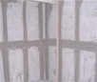 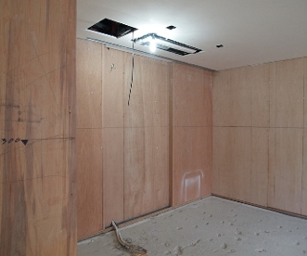 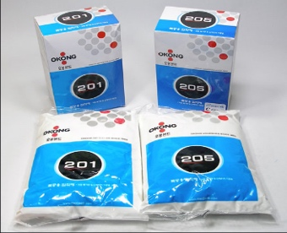 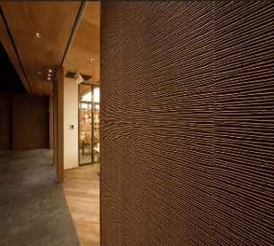

|  |  |  |  |
| --- | --- | --- | --- |
| Concrete frame | Base plywood attachment  (9mm and up) | Attach with water-based  wood glue | Fix with thread tacker pin |

2) Examples of kitchen furniture door installation

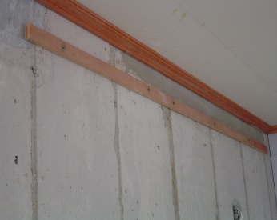 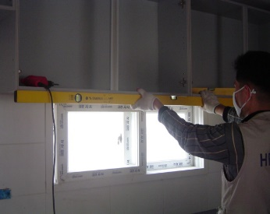 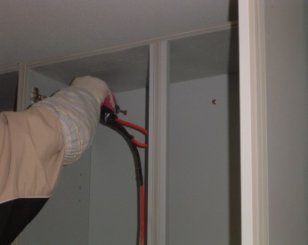 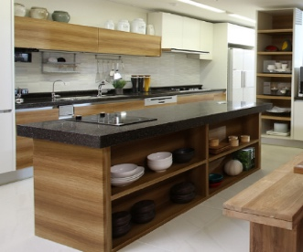

|  |  |  |  |
| --- | --- | --- | --- |
| Fix the installation wood on the concrete frame | Temporary installation of the reference length | assemble the unit length | Installation of the door complete |

3) Examples of storage furniture door installation

 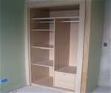 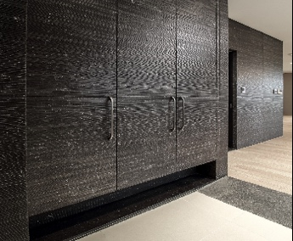 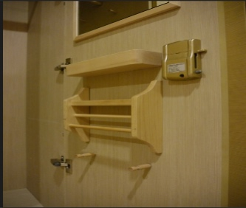

|  |  |  |  |  |
| --- | --- | --- | --- | --- |
| Concrete frame | Assemble the unit length |  | Installation of the door complete | Install the interior accessorie |

5) Examples of installation of house entrance door, fire door and EMP door

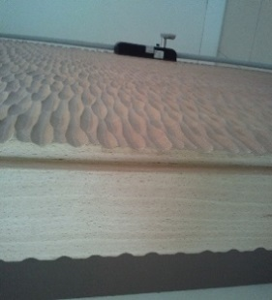

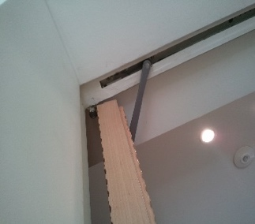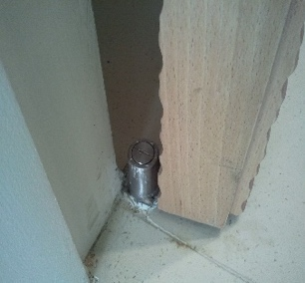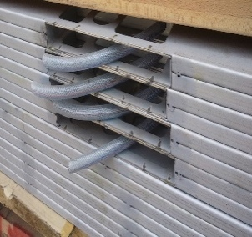

|  |  |  |  |
| --- | --- | --- | --- |
| Internal EMP system | Bottom buried pivot | Upper buried damper | Metal fire-proof door – concave sound-proof finishing |

4) Examples of flush door installation

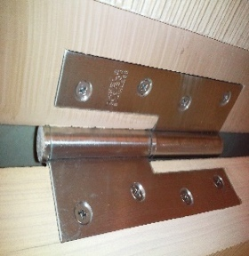 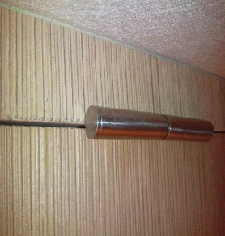 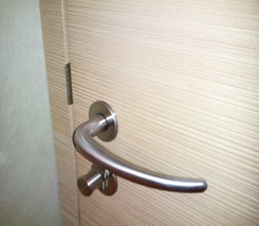 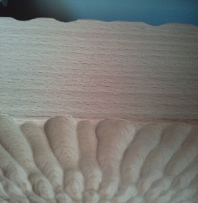

|  |  |  |  |
| --- | --- | --- | --- |
| Inside of the butt hinge | Exterior of the butt hinger | Motis Handle | Patterned wood edge finishing |

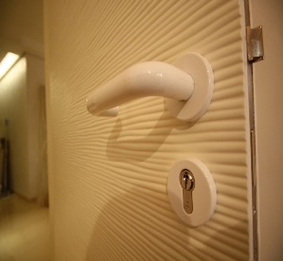 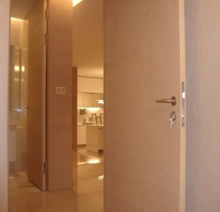 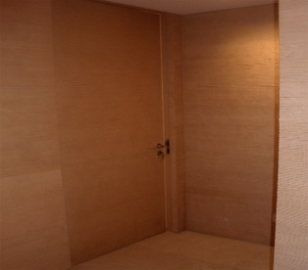 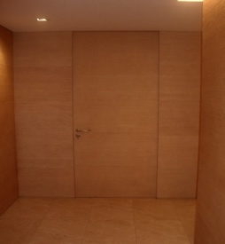

|  |  |  |  |
| --- | --- | --- | --- |
| Color-painted edge finishing | Glazing painting edge finishing | wall panels & doors without casing | Integrated finishing |

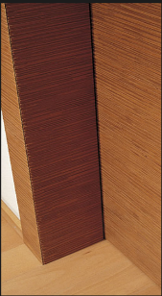 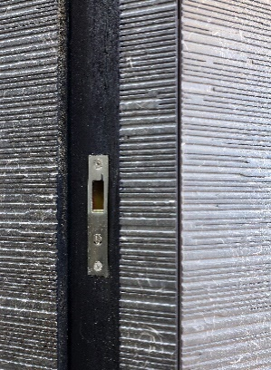 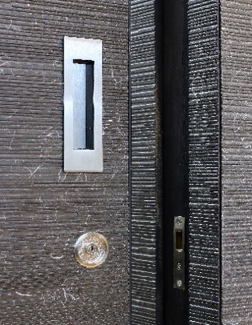 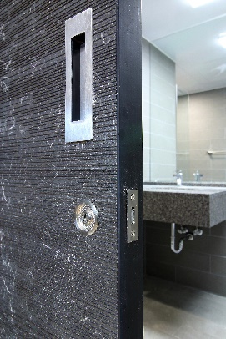 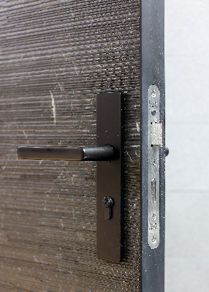

|  |  |  |  |
| --- | --- | --- | --- |
| Corner Askew Casing detail | Edge 2mm Mege Sliding Casing Detail | Metal Frame detail | Motis Metal Frame |

6) Examples of sliding doors and large pivot installations

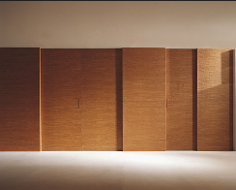 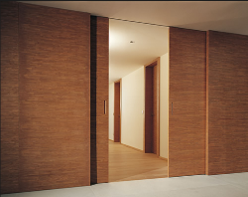 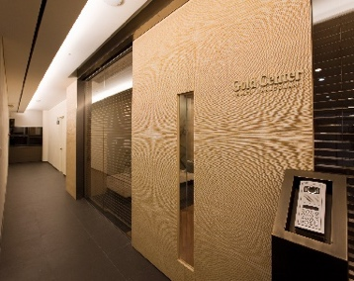 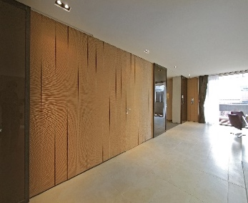

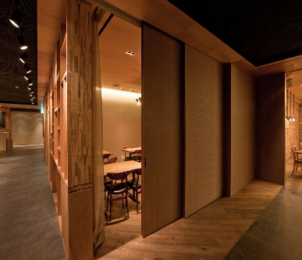 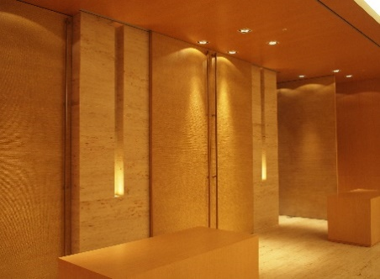 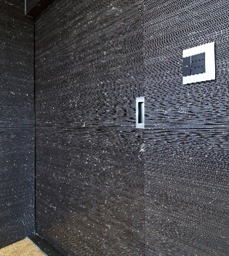 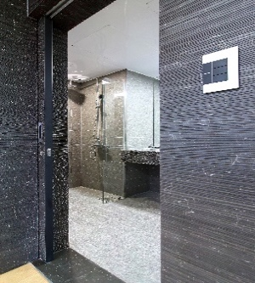

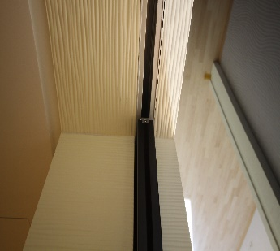 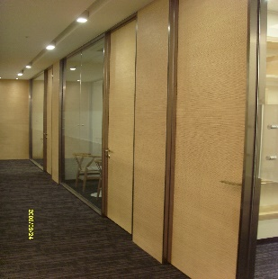 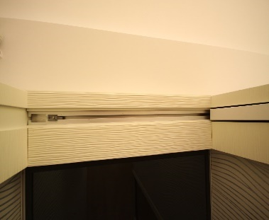 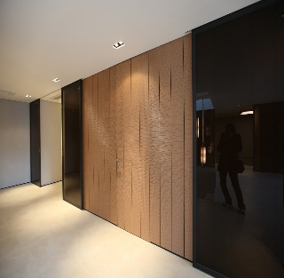

Joining:

A finished board product has a joining that is visible at the edge of the board. While the pattern may continue from one board to another, the joining can become more visible based on the locations of the joining and the 3-dimensional patterns, as well the relative direction of the patterns.

While some models would have less-visible joining, while others’ would be more visible. What is recommended here is that, with regard to the specific installation technique in order to realize the intents of the designers to the fullest, the designer should contact Lanciani. When making such a contact, the designer should provide following information.

* The shared drawing AutoCAD file containing the elevation, cross-section, and layout drawing of the specified area only
* Selection of the unique color number and the name of the 3-dimensional pattern to be used.
* The desired final finishing
* The installation method desired and the site condition
* Edge conditions – See the sample image.

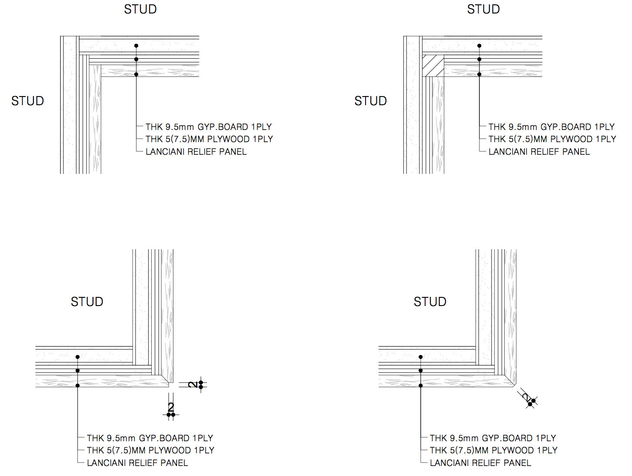

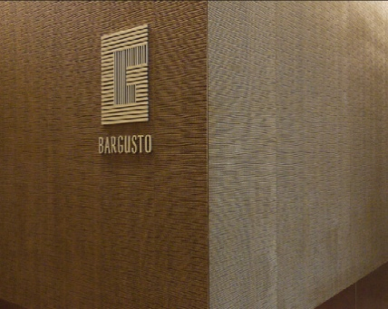 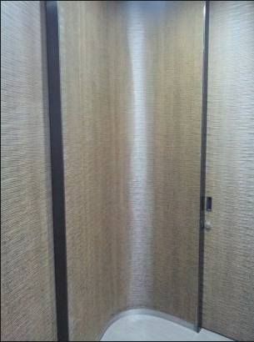 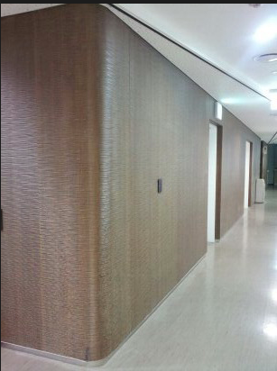

|  |  |  |
| --- | --- | --- |
| An example of the installation of a perpendicular wall | An example of the in-corner wall installation | An example of the out-corner curved wall installation |

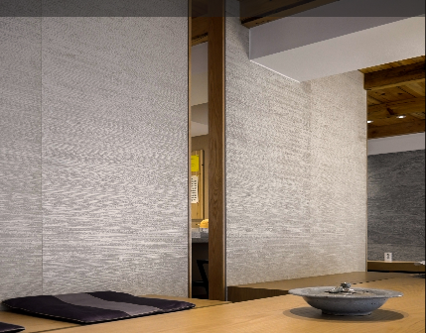 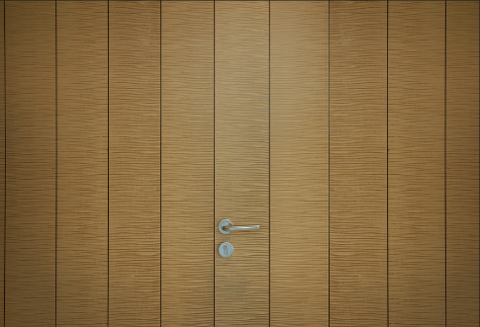 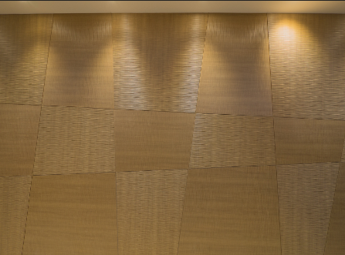

|  |  |  |
| --- | --- | --- |
| An example of butt join installation | An example of the Gap Join installation | An example of Free Divide installation |

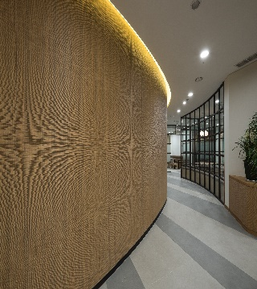 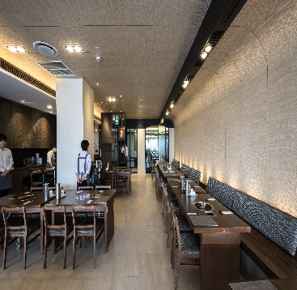 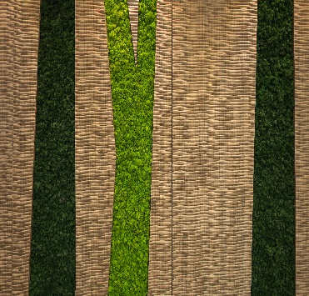

|  |  |  |
| --- | --- | --- |
| An example of installation on a curved wall | An example of the installation on a vertical  round wall and a ceiling panel | An example of the random  processed panel installation |

In consideration of the factors mentioned above, it is possible for Lanciani to make a decision on the suggestion with regard to the optimal installation of the materials joining and the installation method.

The installation of our products should be performed by experienced wood-workers. And, specific design requirements, such as the miter joint for the edges, special environment, and custom-designs, must be mentioned during the initial design phase.

**Additional inquiries to :** [**altnature123@gmail.com**](mailto:altnature123@gmail.com)**/ lanciani@naver.com**

Notice and Disclaimer

All Lanciani board products and related documents are patented. All rights are reserved.

**Membrane Pressed Roll Pattern Overlay:**

Special care must be paid to the convex/concave of the 3-dimensional patterns and the specific directions of the roll patterns including them. The elevation of the 3-dimensional patterns or the forms of the roll patterns are always produced as per rolling and rolling. The horizontal width should not exceed 48”. The architect or the designer must be aware of the required designs for each pattern. This condition may create an unnatural appearance. Therefore, the conditions must be checked and confirmed in writing before commencing the work.

**General:**

Normally, these products are used hanging doors or doors that can move as desired. The board products of ours can be used as the “surface” of the door. However, it cannot be used as a structural member of the entire door structure. Lanciani provides no guarantee for the specific purposes intended by the purchaser nor suitability for specific purposes out of the normal description of the decorative board products.

With additional charges, Lanciani may provide following services;

* All types of miter joint cutting
* Cutting in the rear side of the board or making grooves at the edges
* Submission of the shop-drawing (However, some works may require simple layout drawings, which require prior approval before assembly.)
* Custom-made profiles and patterns (See Note 1)
* Shop-drawing with detailed information (See Note 2)

**Note 1:** All custom-order patterns and profiles should be submitted along with the name and contact information of the creator/designer of the suggested pattern. The suggested patterns cannot be the same or similar to the patterns of the previously launched products. These patterns shall not infringe any copy rights or patent rights. And, Lanciani should be defended and hold harmless against any responsibilities that may arise out of the production of the custom-ordered pattern.

**Note 2:** The capacity of the shop-drawing shall be in accordance with the current work load. And, availability may be limited at times. For the shop-drawing, a fee of $100.00 shall be charged. The cost per hours shall also apply to the review requested by the architect/designer or re-submission.

The quotation of Lanciani shall be based on the proven total and indicated in the floating square meters or by panels, or in the specific volume marked in the quotation.